

Computer Communication Networks

**ASSIGNMENT 1**

Name: Muhammad Ahmed Mohisn

CMS: 33060

Sir: Sir Hassan Khaliq

Contents

QUESTION: 1 2

1.1 Answer 2

1.1.1 Bits: 2

1.1.2 Bauds: 2

1.1.3 Symbols: 2

1.1.4 Bandwidth: 2

Question: 2 3

International Organization for Standardization (ISO 3

Institute of Electrical and Electronics Engineers (IEEE) 3

International Telecommunication Union (ITU) 3

World Wide Web Consortium (W3C) 3

a. IoT (Internet of Things) - 3

b. WiFi - 3

c. NAT (Network Address Translation) 3

d. DNS (Domain Name System) - 3

Question: 3 4

Path: 5

Packet Loss 5

Latency: 5

# QUESTION: 1

Compare the difference between bits bauds, Symbols and bandwidth?

## Answer

We define the following as:

### Bits:

A "bit" is the most basic unit of digital information, representing either a 0 or 1. This smallest unit is what communication systems use to encode and transmit data. The number of bits that are transmitted per second is what determines the speed at which data is transmitted.

### Bauds:

"Bauds," on the other hand, refers to the number of symbol changes or signal events per second that a communication system is capable of transmitting. The baud rate is a measure of the speed at which data can be transmitted and is usually expressed in bauds per second. It's important to note that the baud rate is not always equal to the number of bits per second that can be transmitted. In some communication systems, multiple bits are encoded into a single symbol, and therefore, a higher number of bits can be transmitted in the same amount of baud rate.

### Symbols:

A "symbol" is a specific pattern of bits that represents a specific piece of information. The symbol is the smallest unit of information that can be transmitted in a communication system, and it can consist of one or more bits. The symbol is the basis for digital communication, as it allows multiple bits to be combined into a single unit, allowing for more efficient and higher-speed data transmission.

### Bandwidth:

"bandwidth" refers to the amount of data that can be transmitted over a communication channel in each amount of time. It is typically measured in bits per second (bps) and is an important factor in determining the speed at which data can be transmitted. The bandwidth of a communication channel is limited by the physical characteristics of the channel and can impact the speed and reliability of data transmission. In conclusion, it's essential to understand the difference between these terms in digital.

# Question: 2

Standardization bodies play a crucial role in defining and regulating various communication protocols used in the field of technology. Some of the most well-known standardization bodies include:

International Organization for Standardization (ISO) - An independent, non-governmental international organization that develops and publishes standards in a wide range of fields, including information technology.

Institute of Electrical and Electronics Engineers (IEEE) - A professional association dedicated to advancing technology for the benefit of humanity. The IEEE Standards Association (IEEE-SA) develops and maintains standards in the fields of electrical engineering, computer science, and related technologies.

International Telecommunication Union (ITU) - A specialized agency of the United Nations that is responsible for telecommunications, including standardization in the field of information and communication technologies.

World Wide Web Consortium (W3C) - An international community of experts responsible for developing and maintaining the technical standards that govern the World Wide Web.

Now the protocol standards to explain are as above:

1. IoT (Internet of Things) - The standardization of IoT technologies and protocols is a collaborative effort between various organizations and standardization bodies, including the ISO, the IEEE, and the ITU. IoT standards cover various aspects of IoT systems, including communication protocols, data exchange formats, security, and privacy.
2. WiFi - WiFi technology is standardized by the IEEE, through the 802.11 family of standards. The 802.11 standards specify the physical and MAC (Media Access Control) layers of wireless local area networks (WLANs).
3. NAT (Network Address Translation) - NAT is not a standardized protocol, but various standards organizations have published guidelines and best practices for its use, including the IETF (Internet Engineering Task Force) and the ITU.
4. DNS (Domain Name System) - The standardization of DNS is performed by the Internet Engineering Task Force (IETF) through the Domain Name System (DNS) protocol, which is defined in the Request for Comments (RFC) documents 1034 and 1035.

# Question: 3

Analyze how traceroute traces the route taken by packets to some destination on the Internet.

1. Perform a traceroute to www.icc-cricket.com. How can you make this out from the traceroute output? What is the path taken by your packet to this machine? What other information (latency, packet loss, etc.) can you observe?

By performing the above traceroute for the following address. We have the following output:

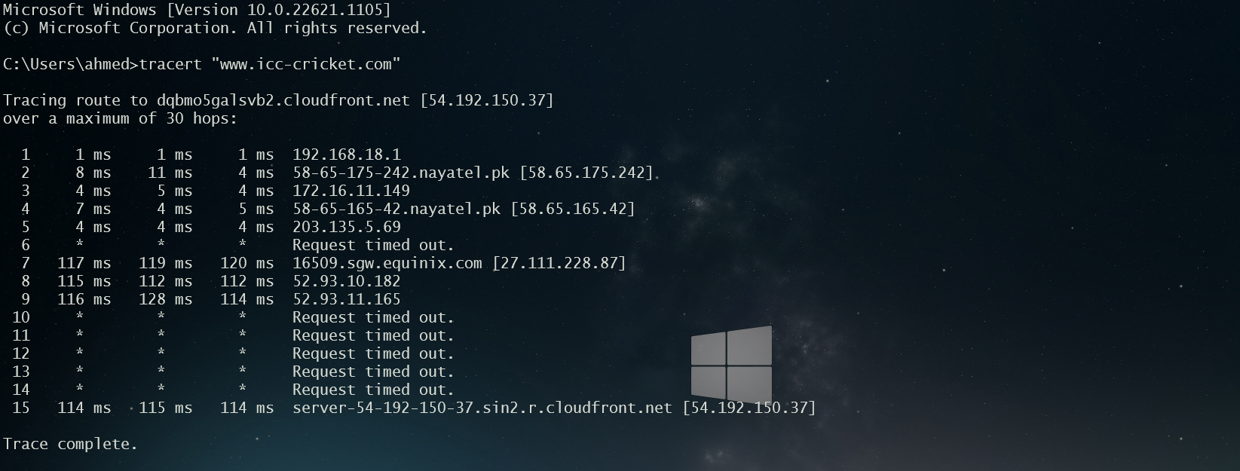

The path taken by our machine is given:

1 1 ms 1 ms 1 ms 192.168.18.1

2 8 ms 11 ms 4 ms 58-65-175-242.nayatel.pk [58.65.175.242]

3 4 ms 5 ms 4 ms 172.16.11.149

4 7 ms 4 ms 5 ms 58-65-165-42.nayatel.pk [58.65.165.42]

5 4 ms 4 ms 4 ms 203.135.5.69

6 * * * Request timed out.

7 117 ms 119 ms 120 ms 16509.sgw.equinix.com [27.111.228.87]

8 115 ms 112 ms 112 ms 52.93.10.182

9 116 ms 128 ms 114 ms 52.93.11.165

10 * * * Request timed out.

11 * * * Request timed out.

12 * * * Request timed out.

13 * * * Request timed out.

14 * * * Request timed out.

15 114 ms 115 ms 114 ms server-54-192-150-37.sin2.r.cloudfront.net [54.192.150.37]

Path: The path taken by the packet can be determined by examining the list of intermediate routers and their IP addresses in the traceroute output

192.168.18.1

58-65-175-242.nayatel.pk [58.65.175.242]

172.16.11.149

58-65-165-42. nayatel.pk [58.65.165.42]

203.135.5.69

16509.sgw.equinix.com [27.111.228.87]

52.93.10.182

52.93.11.165

54-192-150-37.sin2.r.cloudfront.net [54.192.150.37]

Packet Loss**:** Traceroute can also provide information about packet loss. If any packets are lost along the way, they will not appear in the traceroute output. This can indicate a problem with the network, such as congestion or a routing issue.

10 * * * Request timed out.

11 * * * Request timed out.

12 * * * Request timed out.

13 * * * Request timed out.

14 * * * Request timed out.

Latency: The latency between each hop can be determined by examining the RTT values in the traceroute output. Latency is an important factor that can impact the overall performance of a network.

The highlighted part shows latency in each hop.

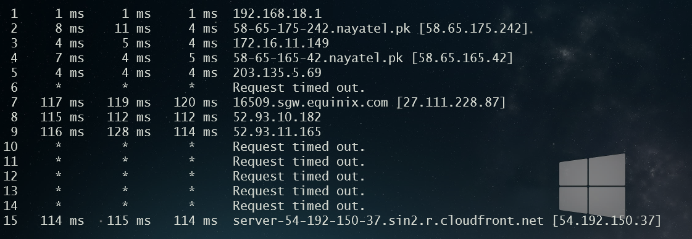

1. Now head to the site: http://www.visualroute.com/index.html and look for the same address. Visualize the path to your IP address (you must provide a public IP address).

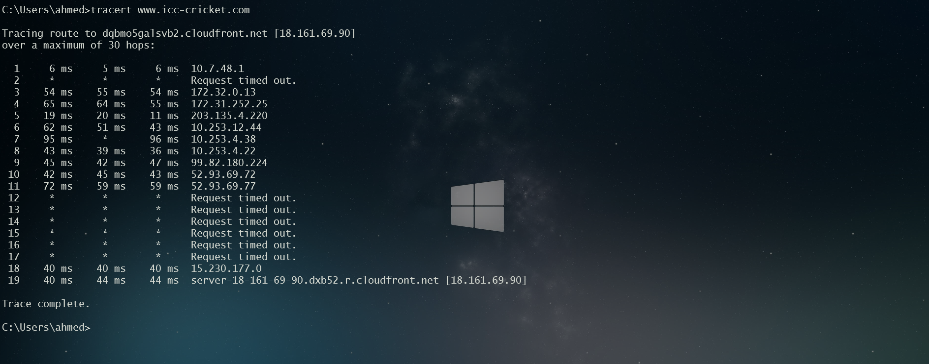

The path covered by our packet according to visualware is shown as:

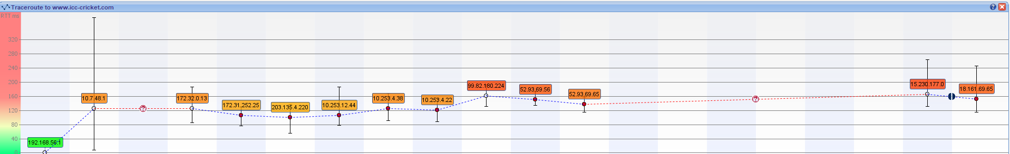

Hence the path covered by the traceroute path and visual ware software are the same